Apr 18 Trading

Monday, April 18, 2016

Liquidated portfolio, reason is index opened down and heading lower.

The situation is not very optimistic today. People are panicking.

Today's tone is bearish with the oil plummeting and Japanese earthquake.

US will likely have a difficult session today, resulting in tomorrow's opening low and tomorrow will be a good opportunity to buy.

Short @ 9637 @ flat, will hold until the close. Today is good for shorting due to the weak open. Investors are unsure what will happen and reluctant to buy.

Markets are slow and directionless. There are no urgent sellers. The situation is quite similar to the following circumstance.

Group.1 Group.2 Group.3 retOPC amFirst5 retCC retCO retCL retAMCO retPMCO

(-0.0192,0.0339] 2 (-0.0249,-0.00514] -0.0036 -0.0073 -0.0214 -0.0179 0.0053 -0.0107 -0.0083

SSH50 has already broken the day high, will be tough to hold this position. If the trading is wrong, come back and reflect on it later.

Very interesting market, a lot of traps everywhere. A vertical pull around 10:36. Hold the short position for a bit until Tuesday AM. Tuesday PM should be eligible for long and we are preparing for that opportunity.

Towards the end of the morning session, markets shot up. Investors chased in. Quite strong indeed. The day trading position is down 50 bps as well.

Do not add position here, just hold until the close.

The market is manipulated in the minute frame. The short and violent pulls are a result of certain big investors trying to move the market.

1400

Future trading at flat at this time, market expecting a rebound. Since the US will need time to absorb this information of the weekend, US will likely underperform on Monday.

Market is trading in a very narrow range today, less than 1% variability. Nothing much to do at this point.

1416

The rebound starts. Today's session is rather insipid.

HK would be much easier to short today.

There are some issues with liquidating the position, as you were chasing it.

You sold at a quite an unattractive level. Make sure to trade T around the position.

You need to do more work on these early morning liquidations. They have been done twice and none worked well. You need to pick better entrance points. When you are shorting, make sure the index is going up, when you are buying, make sure the index is going down. For the liquidating trade today, the index is going down, which was chasing, not good. For the second trade today, the index was going up and the short was put in place which was good. It does not pay to follow the market, always provide liquidity to the market.

Today's take-away

Try to short at more attractive levels.

Pick up positions

At close, day trading was flat. Day trading could have been at better levels. All top levels could have been shortable today.

The point is to determine direction then keep trading in that direction. Today market opened low and went lower, the optimal direction is to short. 11:09 and 14:30 were two shortable opportunities. Since a lot

One general rule about the pmMin is that 1/3 of the pmMin is between 13:00 and 13:30, 1/3 is between 13:30-14:30, 1/3 is between 14:30-15:00.

In terms of pmMax, 13:00-13:30 has 29%, 13:30-14:30 has 34%, the last half an hour has 37%.

No matter short of long, it would be good to take some profits in the first half an hour of the afternoon.

Today the shorting was a bit fast. Knowing the terminal percentile would likely be low, shorting would be preferably done at better levels.

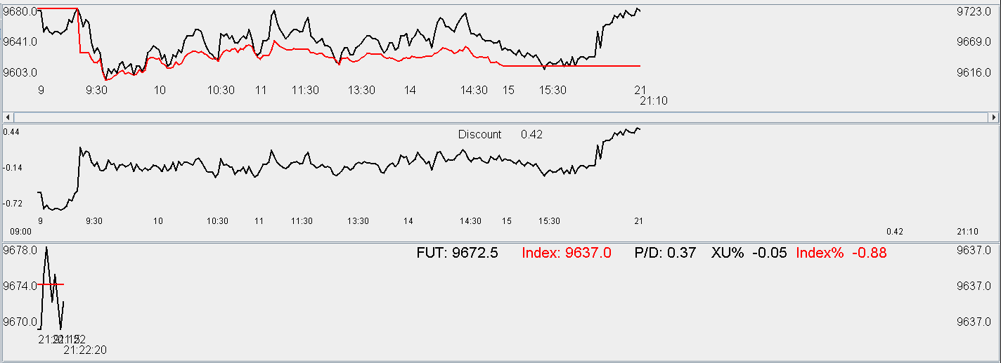

4.19.2016

The short position is being destroyed. Sold at yesterday's AM session and markets massively rebounded into Tuesday.

Fortunately the overnight position is not that big.

I short another unit @ 9722 @ 91 bps premium. Good to hold a bit.

Morning: covered @ 9650 and 9625.

Picked up position at 9630 to be held until the close. I am looking for the 90 bps in rebound.

The trades were well done today. The short at the day's open was classic considering it opened at a 1% premium.

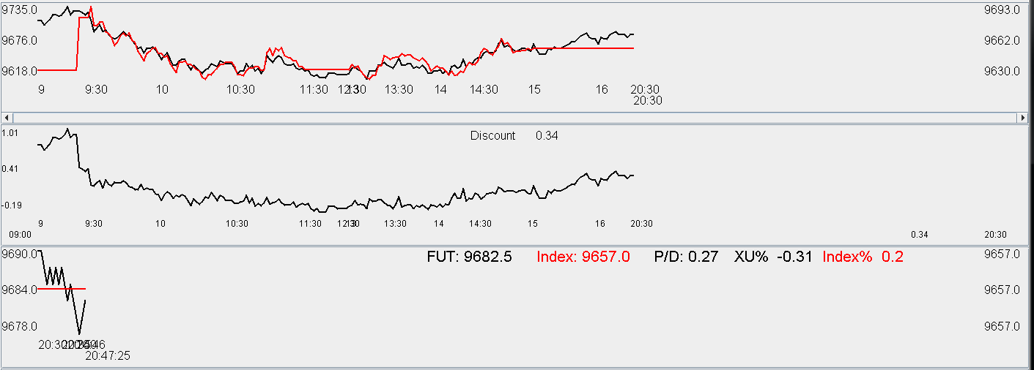

There were basically no mistakes today. Index opened high at 1% premium and short position was put on at this level, the long position was added pretty well. Overall the trades met reasonable standard.

4.20

HK opens weak, futures pushed back to +0.2% premium.

Shcomp opens up 0.25%.

9692 picked up 1 unit. Reason is first minute up. Now long 3 units, hold.

Markets seem weak. The strong first minute generate favorable distribution for both CL and CH. Therefore this is a good opportunity to hold. A50 fut volume dried up with investors not sure what to do.

Markets are weak. Investors are clearing out of position.

Markets trading at flat. Not much to do today.

It was interesting to observe the opening behavior of HSCEI fut at the open. One can't help but think that the market possesses more information at certain point and this needs to be taken note of.

Markets don't want to go up at this point. Futures gave back all of its premium.

Always make sure that you are provider of liquidity.

Volume is very low. H share future continue to break day low -> wait a bit.

Day high appeared too early today. I don't plan on increasing position.

Try to get rid of some position before tomorrow. No volume, nothing to trade.

When H share is weak be careful. There might be information in that move. H share was crashing lower this morning with no rebound at all. This should raise some flags.

Market has been trading in a 1% range for 3 days. There is no realized.

Today is prototypical typical day.

Never forget you are a liquidity provider and all you do is provide market with liquidity. Do not take away liquidity.

Pay attention that heavy position is permissible only if T-1 was a crash or closed at the day's low.

Down quite a big at this point. No more buying.

Cuing @ 9590. Now I am long 5 lots.

Delta is down 1.5%. The panic is pretty interesting. It is almost vertical.

Today might be a bit rash in trading. Position is quite heavy now. Get ready for a 10% drop today.

Practice with mentality, big position management, psychology etc.

Market crashes into the AM close with the high in the early AM. The situation is not that pleasant. Position is already quite heavy – nothing much to be done here.

Given the usual Wednesday strength, one might be complacent and it is times like this that one might suffer a big loss and learn the lesson to be more careful.

Market is apparently in a huge panic.

Titrate your risk, increase your risk tolerance, provide liquidity, manage risk.

Casino: limit risk on each bet, probability advantage, and let probability take over in the long run. Today don't increase any more position.

Hold the position for a while and slowly disseminate towards the expiry.

2% offside so far.

No more play today.

Liquidation reason: Negative noonChg. Negative pmFirst5. Possibly sold at the lowest level of the day.

What is the reason for this loss?

1. Position is too heavy due to complacency of Wednesday having positive return. Accumulated 80% of the delta in the morning. This was apparently too much.
2. Today the amMaxT is in the morning, there should be a hard limit on the position size in these sort of situation.
3. The cut was at the worst time, but it had to be done because the morning max was in the
4. This is the first time experiencing a crash. This exposes the weakness of buying on the dip. Massive loss will occur because too much position will have accumulated on this day. First of all, a position limit needs to be placed in this type of the situation.
5. Must cut position to avoid further losses on these kinds of days. Develop cutting principles: amMaxT1, amMinT1, noonChg. pmFirst10.
6. Position can be built tomorrow if it goes higher. Build it slowly. Do not increase to over 3 lots.

Later, the futures rebounded by 200 points, this is 1000 points which I threw away.

Today is good experience as it taught you that having a big position affects trading performance.

The position was sold at absolute low because that's where the panic comes. Having 80% of the entire portfolio is sure to make you want to exit at all costs and you were a liquidity provider taker instead of a provider.

Some things to note going forward:

1. No more than 50% allowed under all circumstances.
2. No more than 30% allowed when amMaxT1 is in the morning.
3. Today the position adding was too aggressive. Entered the day with 2 lots. Added at the open, 10:37 and 10:57, this amounted to 5 lots and over 80% of the portfolio. This is why in the early afternoon, potential return was given up in order to preserve capital.
4. In the early afternoon, all I had in my brain was the case of index down 10%. One must be prepared for this scenario in order to be a liquidity provider.
5. Your capital base is too small for you to act too aggressively as you did today. It cannot withstand as much volatility as the big players.
6. Reduce position, still provide liquidity.

Thursday, April 21, 2016

Today is Thursday.

1. don't let trading affect mood
2. don't take big position (3 lots max now)
3. Always trade with expected return in mind. (Take risk at the most panicking spots)
4. Be prepared to take max losses and be OK with it -> decide position accordingly. Be OK with 20% of max loss.
5. Buy once per session. Can buy at AM close or PM open.
6. Trade in the direction of first 5 minutes.
7. Don't buy at top percentile.
8. Don't sell at bottom percentile.
9. Trade in AM open(look at what the index does in the first 5 minutes, determine strength) , AM close, pmClose.
10. Wait until panic to buy. Down 3-5% is panic. When people with full position dump their position, it is time to enter.

0.8% discount right now. Cannot short here. Wait until later to trade. Wait until the situation is relatively clearer. After first 5 minutes is done, the situation becomes clearer. Use 1 lot to follow with the general trend. When vol becomes higher, cut position size. Play small.

Picked up at 9532. Reason: Opened low, first five minute is stable. Can long a bit.

Markets are rallying. Position would be roughly flat if held until now.

It is essentially a wealth transfer between ones with full position vs. ones with no position.

Lessons like this teach you that in order to withstand volatility, one must be prepared for.

This puts in question about the previous entry points, which were not rigorous enough. Five lots (80%) could not withstand volatility and it could therefore be expected that you would be the victim of panic selling.

Morning cannot exceed 2 lots, afternoon can add 1. That's it. Preserve capital. Use it in the most panicky places.

Market recovered all of its losses. This shows that positioning needs to be light before panic occurs.

If positioning was not so heavy yesterday, could have been able to escape unscathed this afternoon.

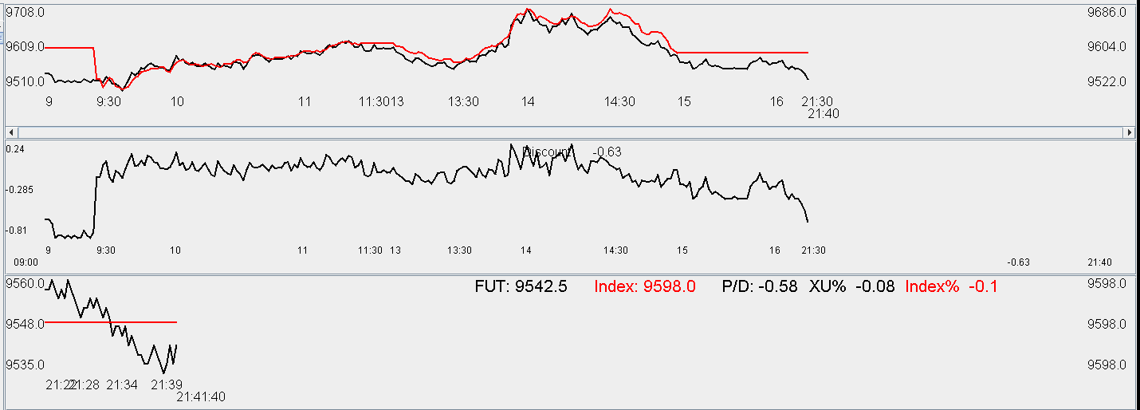

Apr 22

Stick to the principle of buying on the day's lows and selling on day's highs. Doing this did not cost me any money.

Weekly recap:

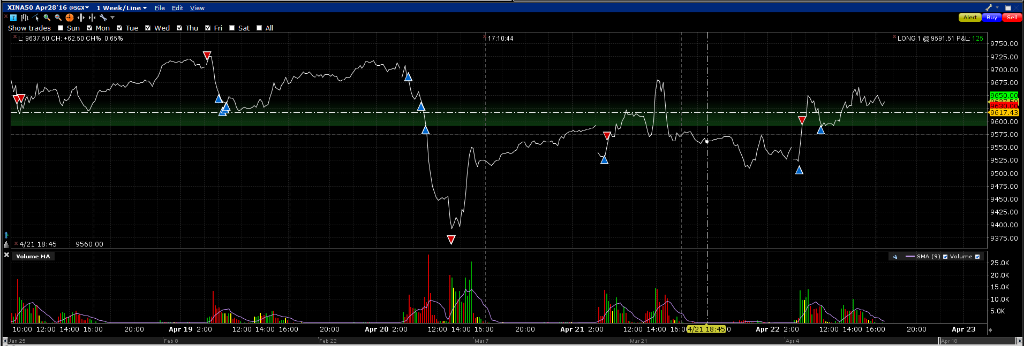

Mon:

Tue: Sold in the morning, was well done.

Wed: position accumulated too quickly.

Thu: ok

Friday: ok. Second buy was good. AmClosePercentile does have a bearing on percentile.

Lesson:

Do not exceed 50% in any circumstances. Each half session buy once is enough. Each day, maximum size to buy is 2 lots. Once start dropping stop buying, buy at noon on Tuesday, Wednesday, Friday.